Subcellular Localization Prediction
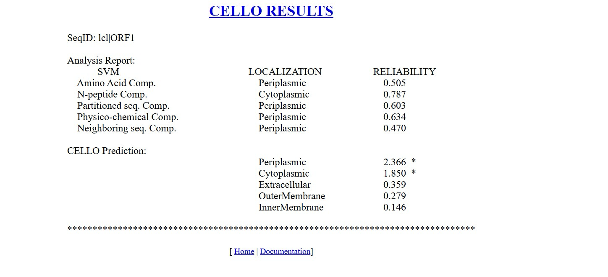
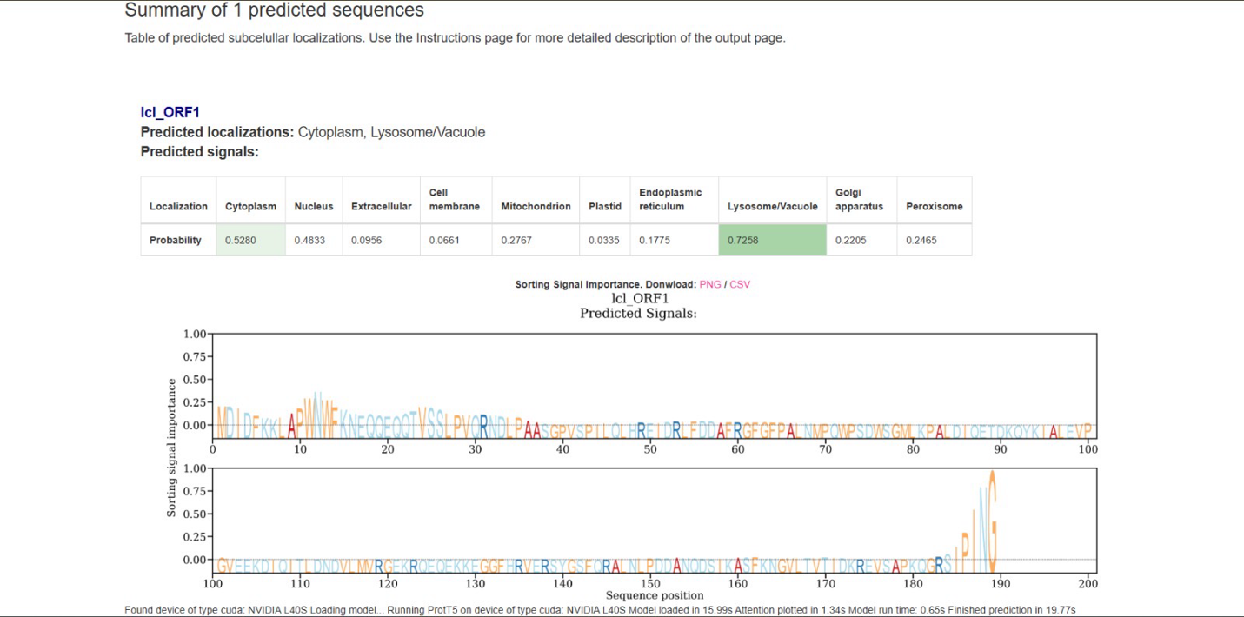

Final predicted subcellular location: Periplasmic

Justification
1. CELLO results (prokaryotic-focused predictor):
• The highest CELLO score is for Periplasmic (2.366*), clearly exceeding Cytoplasmic (1.850*) and all other compartments.
• Multiple independent feature sets within CELLO (amino acid composition, partitioned sequence composition, physicochemical properties, neighboring sequence composition) consistently favor periplasmic localization.
• Reliability scores for periplasmic predictions (≈0.60–0.63) are reasonable and collectively stronger than alternatives.
2. Relative ranking of locations in CELLO:
• Periplasmic > Cytoplasmic >> Extracellular / Outer membrane / Inner membrane
This hierarchy strongly supports a periplasmic assignment rather than a membrane-embedded or extracellular protein.
3. Second tool output (ProtT5-based eukaryotic-style prediction):
• It suggests Cytoplasm / Lysosome-Vacuole, with the highest probability for Lysosome/Vacuole.
• However, lysosome/vacuole is a eukaryotic compartment, which is not biologically compatible with a bacterial ORF (icl_ORF1).
• Therefore, this prediction is likely due to model mismatch (using a eukaryotic-trained predictor on a prokaryotic sequence).
4. Biological consistency:
• CELLO is specifically designed for bacterial subcellular localization, making it the more appropriate and reliable predictor here.
• The absence of strong inner/outer membrane signals further supports a soluble periplasmic protein.

